# LED Fade Using Pulse Width Modulation

**OBJECTIVE:** PWM is a type of Digital Signal. A Digital Signal can have only two possible states, ON or OFF, 0 or 1, or in the case of this project, 0 or 3.3 volts. That’s why making the LED blink didn’t require PWM, because the LED was simply turning ON and OFF. In PWM signals, we can have both of these two states for a specified time period.

Suppose you want to control the brightness of an LED, the possible approach is to turn on an LED for a small period of time and then turn it off again for a small period of time. So, when this ON and OFF happens at very high speed, it gives the effect of dimmed LED.

### **COMPONENTS:**

1) RPi 3

2) Breadboard

3) 100 Ω Resistor x 4

4) LED x 4

5) Connecting Wires



# CIRCUIT DIAGRAM:

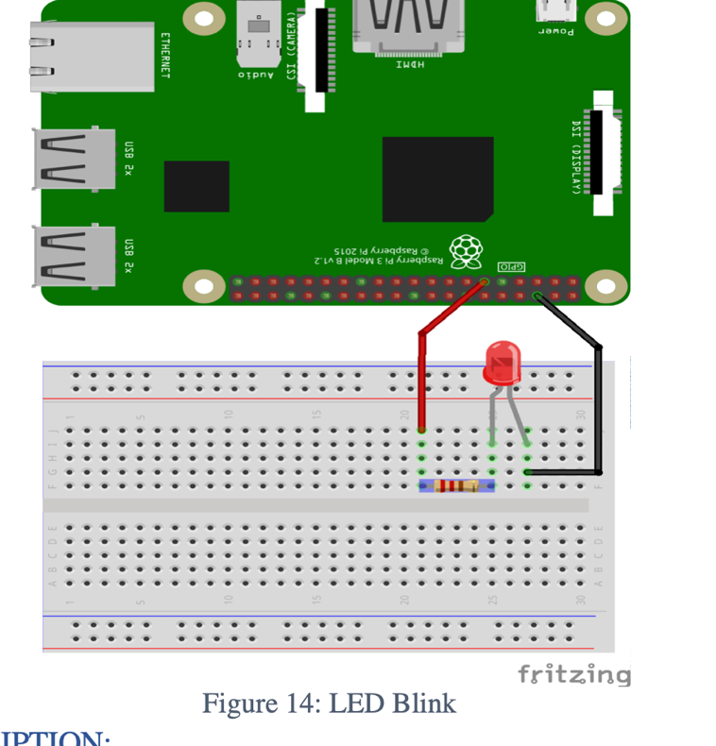

Connect the pin# 11 of RPi with 100 Ω resistor, and connect the other side of resistor with the positive (+) of LED. Connect the negative (-) of LED to the ground (GND) of RPi Pin# 6. Resistor is used to limit the current.

Code

**import** **time**

GPIO.setwarnings(**False**)

GPIO.setmode (GPIO.BCM)

GPIO.setup(17,GPIO.OUT) *# initialize GPIO17 as an output.*

p = GPIO.PWM(17,100) *# 100Hz frequency*

p.start(0) *#start at 0% duty cycle*

**while** **True**:

**for** x **in** range (50):

p.ChangeDutyCycle(x)

time.sleep(0.1)

**for** x **in** range (50):

p.ChangeDutyCycle(50-x)

time.sleep(0.1)